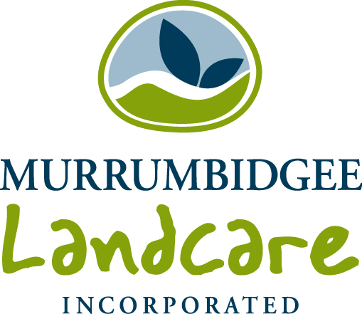
Funding Application Form

Through the Regional Landcare Facilitator project, funding is available to support groups within the Murrumbidgee catchment in their day to day activities. The funding is aimed at supporting groups to continue their NRM work and could be used for such things as newsletters, events, guest speakers, tools and safety equipment. $500 to $1500 per group is available, depending on need. Applications for greater amounts will be considered.

To apply for funding, please complete the form below and return to:
Attention: Wendy Minato
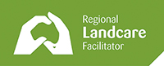
rlf@mli.org.au
or
Murrumbidgee Landcare Inc.
PO Box 710,
Wagga Wagga NSW 2650

Group details
Contact Person
Name of group
Address

Phone
Email
Location of group activities
No. of members – paid or participating
Office Bearer 1
Name
Position
Phone number
Office Bearer 2
Name
Position
Phone number

Please describe the group’s current / proposed activities
Please describe how this funding will (where applicable):
- respond to community interest or need;
- build capacity within your group or the community
- assist your local community to achieve NRM goals?
Budget

Estimate the costs associated with whatever items or activities you are requesting assistance with. If appropriate, obtain quotes for supply or services and attach to your application

Item / Activity | Description | Cost
Total amount requested
Office use only
 | Name | Signature | Date
Approved by RLF
Approved by MLi


