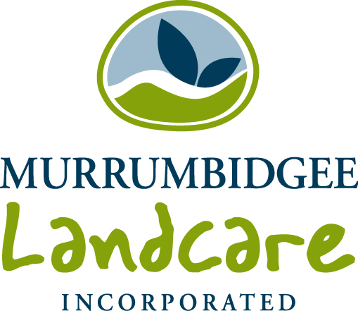
National Landcare Conference
Funding application form

Through the Regional Landcare Facilitator project funding is also available to support community Landcare members to attend the National Landcare Conference in Melbourne on 17th-19th September 2014. The funding is to cover conference registration costs and the National Landcare Awards dinner and is offered on a first-come, first-served basis. Community Landcare members are encouraged to apply sooner rather than later.
All funded attendees will be requested to submit a brief story about a topic of interest at the Conference of relevance to Landcare in our region for e-publication.
To apply for funding, please complete the form below and return to:
Attention: Wendy Minato

rlf@mli.org.au
or
Murrumbidgee Landcare Inc.
PO Box 710,
Wagga Wagga NSW 2650

Name
Address

Phone
Email
Name of Landcare group
Why I am interested in attending the conference
In signing this application, I agree that I am prepared to submit a brief story about a topic of interest at the Conference of relevance to Landcare in our region for e-publication.

Signature:

Date:

Office use only
 | Name | Signature | Date
Approved by RLF
Approved by MLi



